Seesaw Instructions 3 – Student Access
Seesaw – Student

How to: Download Seesaw to an iPhone, iPad or a tablet and Log in using the Student Seesaw App.
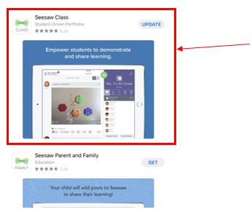 | Download the Seesaw Class App  (There are 2 apps for Seesaw. Seesaw Class is used for students. For parent communication with your child’you need to use the Seesaw Parent and Family App.)
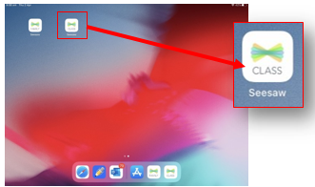 | Tap to open the ‘CLASS Seesaw’ app
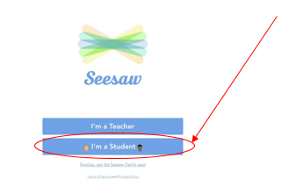 | Click ‘I’m a Student.’
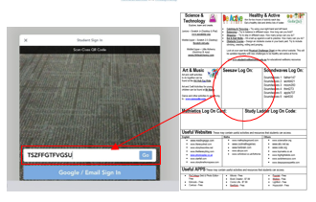 | Enter the ‘Seesaw Log On’ code from your child’s Learning Grid and press ‘Go’  (Student Learning Grids were emailed home in week 8. If you cannot locate yours please contact the school office 9232 3600.)

How to: Download Seesaw to a Computer
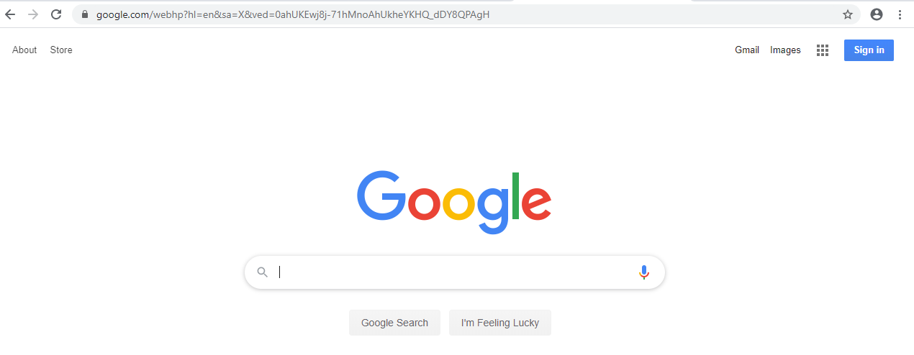 | Search the internet using your web browser such as Google or Ninemsn etc. Enter the website address  www.web.seesaw.me
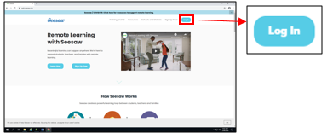 | Click ‘Log In’  (On the top right of the screen click on the blue log in tab)
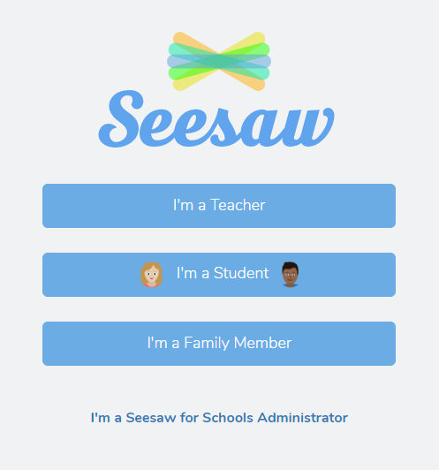 | Click ‘I’m a Student’
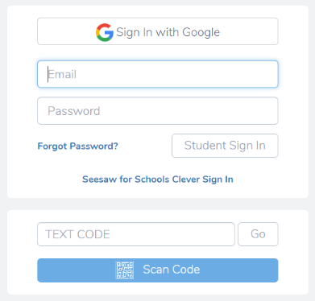 | Enter your ‘Seesaw Log In code’  This code is in your ‘Home Learning Grid’ that has been emailed out to all parents.
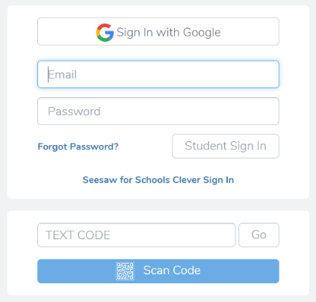 | Press ‘Go”

