Seesaw Instructions 2
Parents – Seesaw Mobile Devices

How to: Download Seesaw to an iPhone, iPad or a tablet and Log in to the Parent Seesaw App.
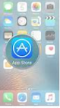 | Go to the App Store on your device.
 | Search for Seesaw Family
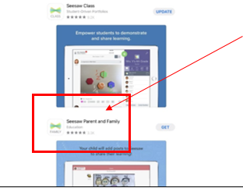 | Download the Seesaw Parent and Family App  (There are 2 apps for Seesaw. Seesaw Class is for the students and Seesaw Family is for parent communication and viewing of your child’s journal. You need to select Seesaw Family.)
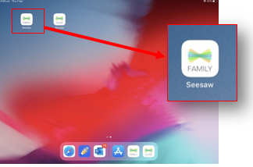 | Tap to open the family App
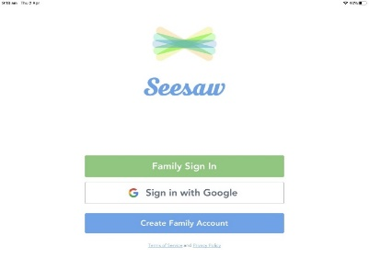 | Tap “Family Sign In”.  If you have not yet “accepted” an invitation from your child’s class teacher please go to Seesaw Instructions 1 which explains how to accept the this invitation.
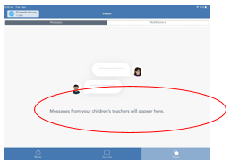 | Once logged in, you will be able to see your child’s journal and Inbox your child’s teacher/s.

How to: Log in to the Seesaw website on a computer for Parents.
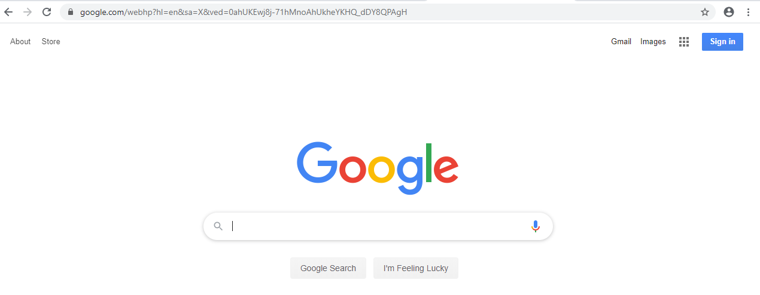 | Search the internet using your web browser such as Google or Ninemsn etc. Enter the website address  www.web.seesaw.me
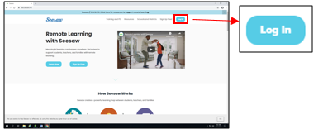 | Click ‘Log In’  (On the top right of the screen click on the blue log in tab)
 | Click ‘I’m a Family Member’
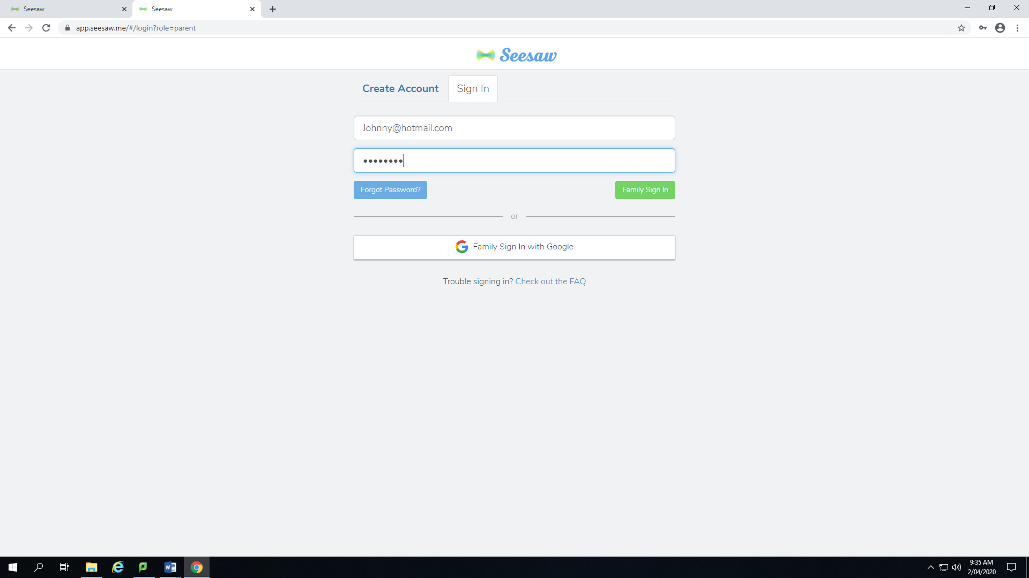 | Enter your email address and password.  Ensure you use the email you used when you accepted your invitation.  If you have not yet “accepted” an invitation from your child’s class teacher please go to Seesaw Instructions 1 which explains how to accept the this invitation.
 | Press ‘Family Sign In’
* See the You Tube links below for a video demonstration of how to download the Seesaw App to Android and Apple devices

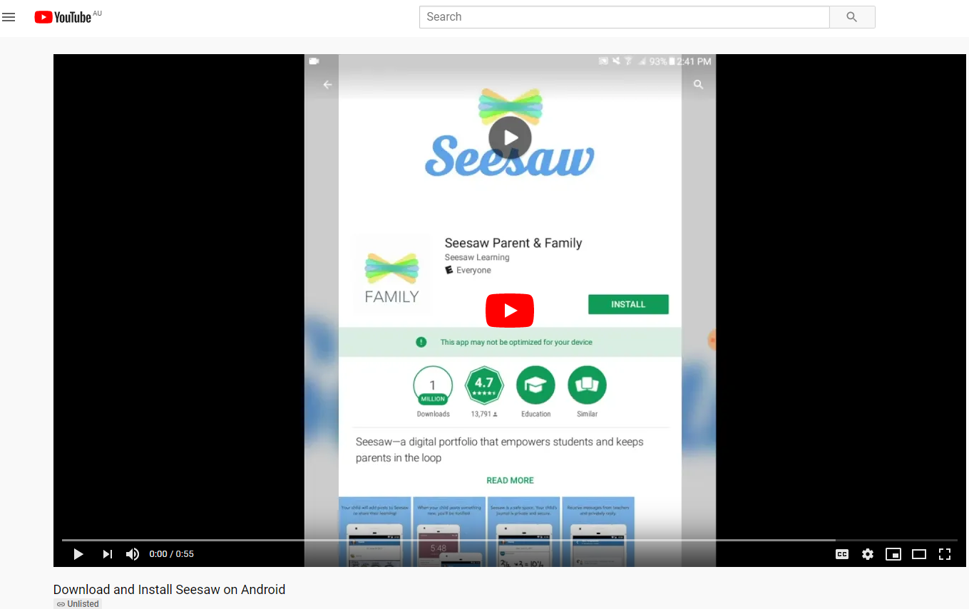
https://www.youtube.com/watch?v=wng_zTWU0FE&feature=emb_title
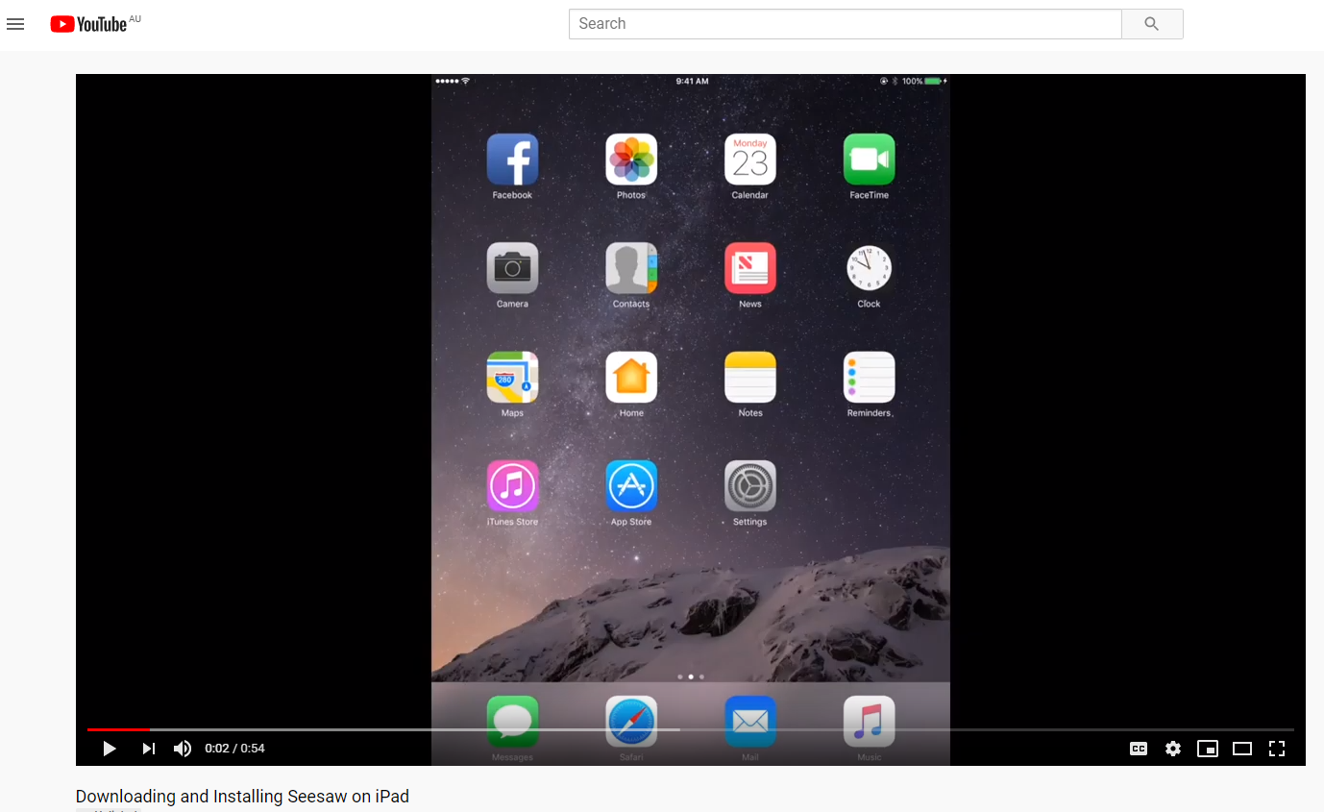

https://www.youtube.com/watch?v=TgAVbZIGLI0&feature=emb_title

