Seesaw Instructions 1 - Invitations
How to Accept a Seesaw Invitation

When the class teacher sends you an invitation to join Seesaw, use these steps to accept.
This can be done on any device including mobiles, iPads, tablets or computers.

 | Open your email account. Find an email from Seesaw with an invitation from your child’s class teacher.
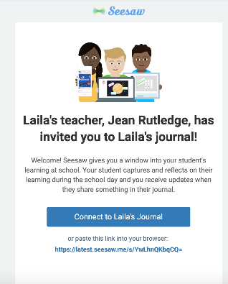 | Click on the email. It will open to an invitation from the class teacher.
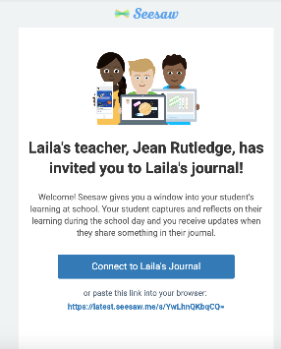 | Click on ‘Connect to (Your Child’s Name) Journal’
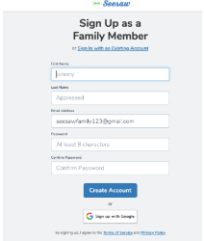 | You will be transferred automatically to a webpage called  ‘Sign Up as a Family Member.’
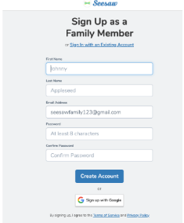 | Enter your details in and tap ‘Create Account”
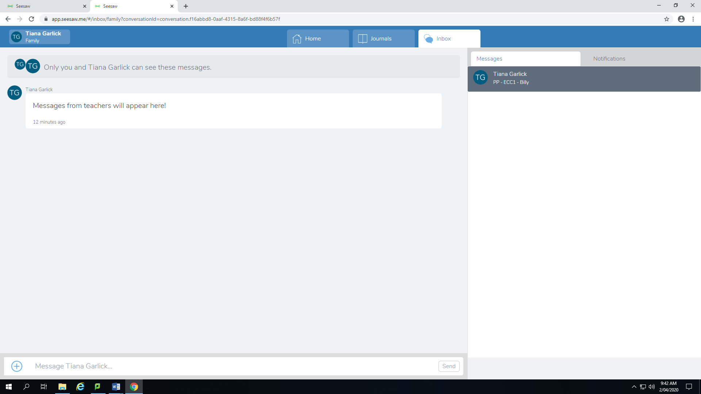 | You are now logged in to your account.

