SeeSaw Account Information:
Student and Parent Accounts

Seesaw is used differently between the student and parent accounts.
Parents can use their accounts to communicate to teachers and students use their accounts to complete tasks.
Below explains how to login to each account, what you can access and when you would use each account.

 | How to Login | What You Can Access | When to Use
Parents | - An invite was sent via email or sms.  (if you have not received one please contact administration on 9232 3600)  - Open the email.  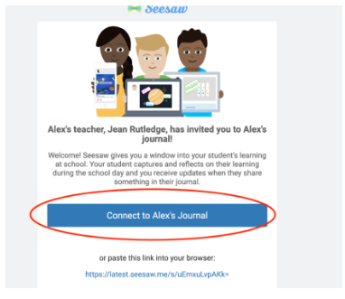  - You need accept the invite by pressing ‘connect to xxxx’s journal.’ ( xxx is your child’s name)  This can be done by:  - Logging onto https://web.seesaw.me/  - Download an app onto your mobile.  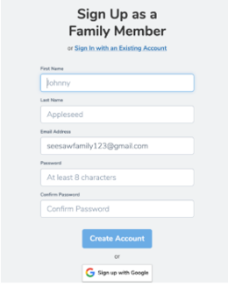  - Sign up: | - Your Child’s Journal  This will include tasks that your child has completed.  - Inbox  Private communication between you and the teacher.  - Announcements  Teachers can send announcements to all families which may be used for reminders, updates or general information. | This account is used by parents to be able to view their child’s completed work, privately message teachers or to check any announcements and updates.
Students | 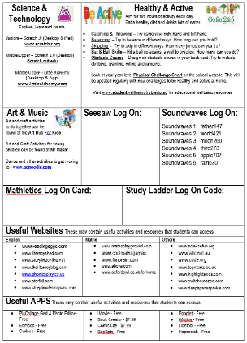  - Students were given a code on their learning grid that was emailed to parents.  - You need to enter the code on:  - Computer: https://web.seesaw.me/  or  - iPad/tablet App | - Journal  This will include tasks that they have completed.  - Inbox  Private communication between child and teacher.  - Activities  Students can complete activities that have been assigned by the teacher. They can also upload any other work that have completed by pressing . | This account is to be used by students to complete work, upload work, message their teacher or view their learning journal.

